**Linux basic command Assignment**

**Playing with files**

1. Create a file like nano file1.txt

* Edit some data and then save the file

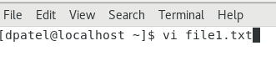

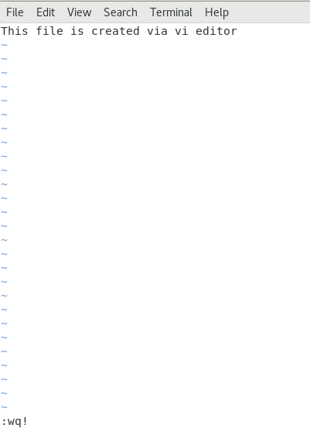

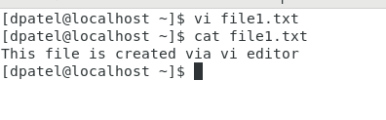

2. Now we will copy date from file1 to new file2

* cp file1.txt file2.txt
* Then see the output of file2.txt, cat file2.txt
* Give screenshot

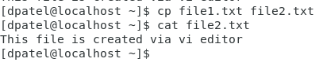

3. Now we will move the file2.txt to new folder /home

* mv file2.txt /home
* Then go to home directory and check ls, file exits or not?
* Given screenshot

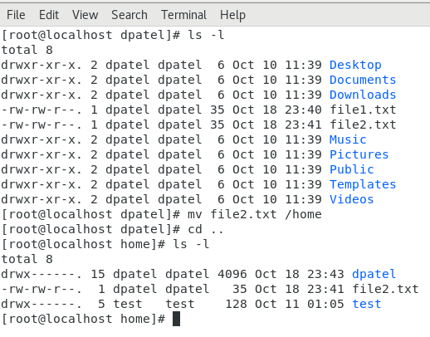

4. Then we create a new file3.txt and file4.txt in home directory and add

content in it.

* Now do echo “Hello I am newline” > file3.txt and provide the

output of file3.txt

* Now do echo “Hello I am newline” >> file4.txt and provide the

output of file4.txt

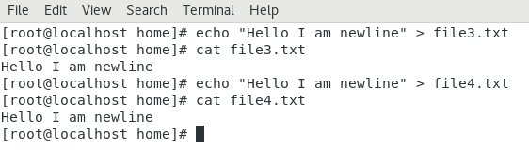

* Tell the different between both step you follow and the reason

behind it

**Using Vi Editor we can edit anything i.e. any line or any paragraph but using this method we can only overwrite the file with new set of data at runtime.Old data will be replaced with new data.**

5. For remove a file or directory you can use the below two commands

* To delete a file – rm <any_filename>

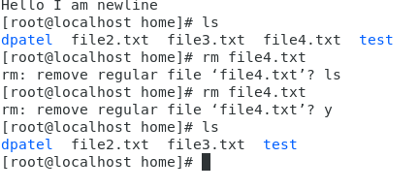

* Tpo delete a directory -rmdir <any_dirname>

